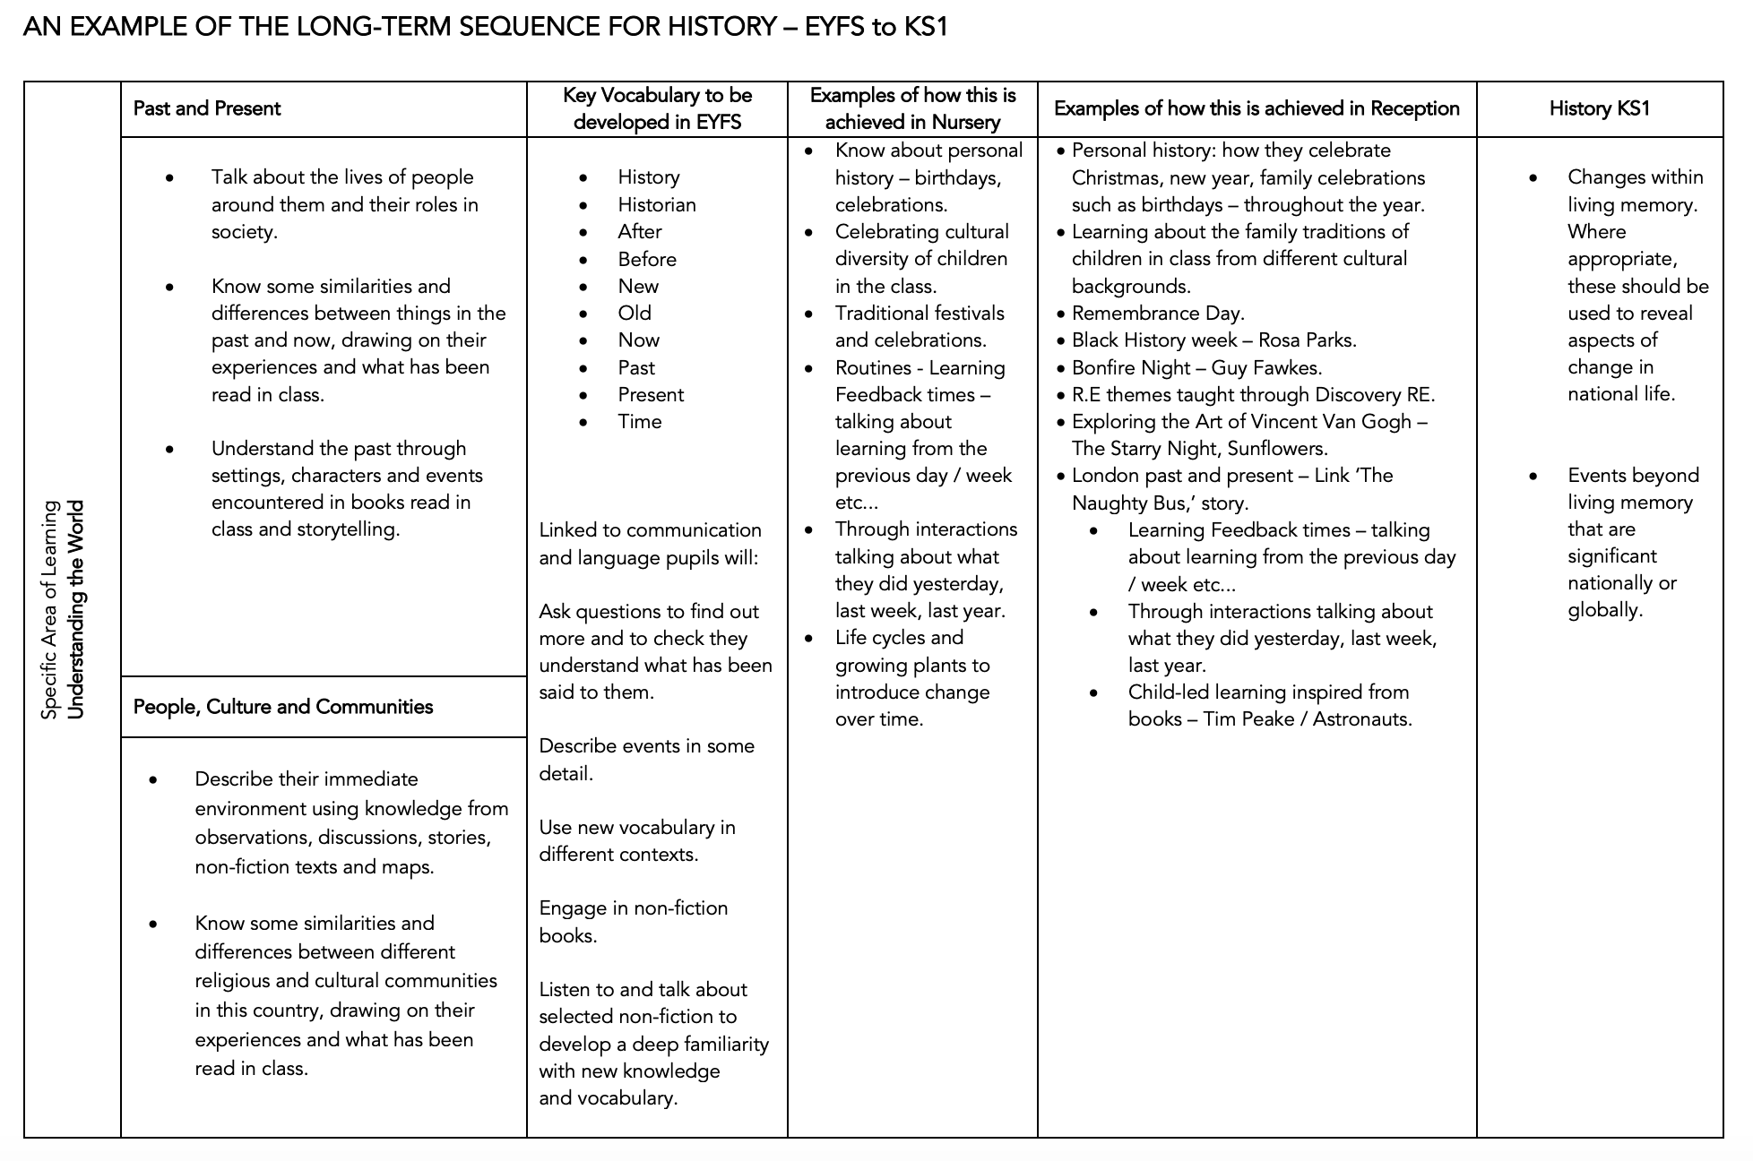


PREVIOUS KNOWLEDGE FROM EYFS - Understanding the world Past and Present Talk about the lives of the people around them and their roles in society. Know some similarities and differences between things in the past and now, drawing on their experiences and what has been read in class. Understand the past through settings, characters and events encountered in books read in class and storytelling. People, Culture and Communities Describe their immediate environment using knowledge from observation, discussion, stories, non-fiction texts and maps. Know some similarities and differences between different religious and cultural communities in this country, drawing on their experiences and what has been read in class. Explain some similarities and differences between life in this country and life in other countries, drawing on knowledge from stories, nonfiction texts and – when

SUBSTANTIVE CONCEPTS – 5 BIG IDEAS – COMMUNITY. KNOWLEDGE. INVASION. CIVILISATION. POWER. DEMOCRACY

PREVIOUS KNOWLEDGE FROM EYFS - Understanding the world Past and Present Talk about the lives of the people around them and their roles in society. Know some similarities and differences between things in the past and now, drawing on their experiences and what has been read in class. Understand the past through settings, characters and events encountered in books read in class and storytelling. People, Culture and Communities Describe their immediate environment using knowledge from observation, discussion, stories, non-fiction texts and maps. Know some similarities and differences between different religious and cultural communities in this country, drawing on their experiences and what has been read in class. Explain some similarities and differences between life in this country and life in other countries, drawing on knowledge from stories, nonfiction texts and – when

SUBSTANTIVE CONCEPTS – 5 BIG IDEAS – COMMUNITY. KNOWLEDGE. INVASION. CIVILISATION. POWER. DEMOCRACY

