

**Our results**

We are proud of the results our pupils achieved in 2017. Take a look at how we did.

**EYFS**

83.3% of our pupils achieved a good level of development

**Year 1 phonics screening**

Year 1 – 63%

Year 2 – 100%

**Key stage 1 Reading**

**Children working at the expected standard**

100% were working at the expected level

20% were working at greater depth

**Key Stage 1 Writing**

**Children working at the expected standard**

80% achieved the expected standard in writing

40% were working at greater depth

**Key Stage 1 Maths**

**Children working at the expected standard**

90% achieved the expected level

30% were working at greater depth

**Our Key stage 2 results 2016**

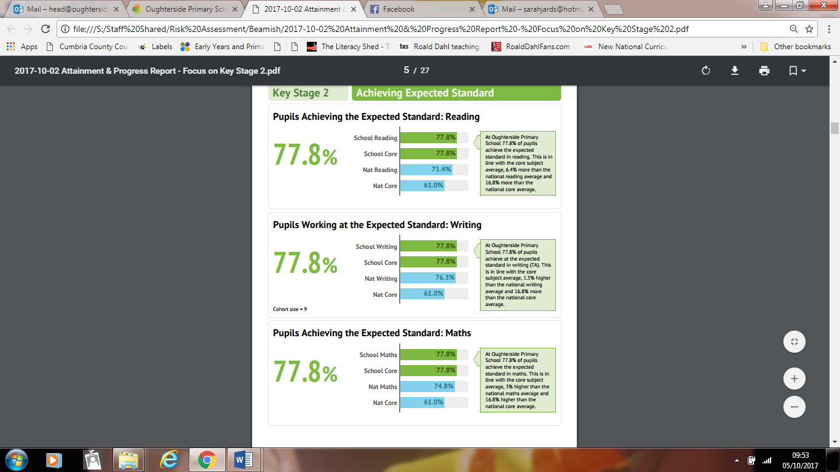

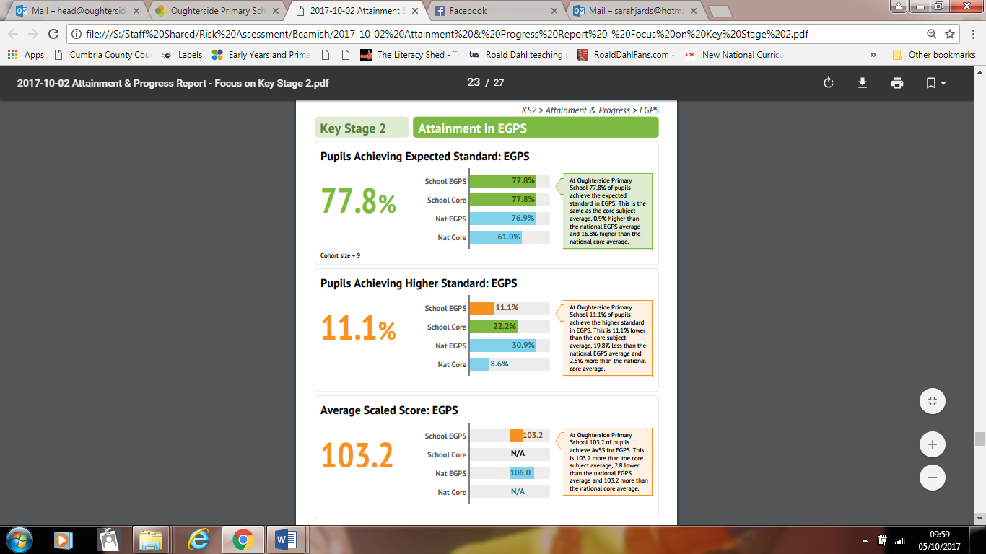

**Our scaled scores were:**

**Reading - 106.1 (national 104.1)**

**Maths – 103.7 (national 104.2)**

**Pupils achieving the higher standard**

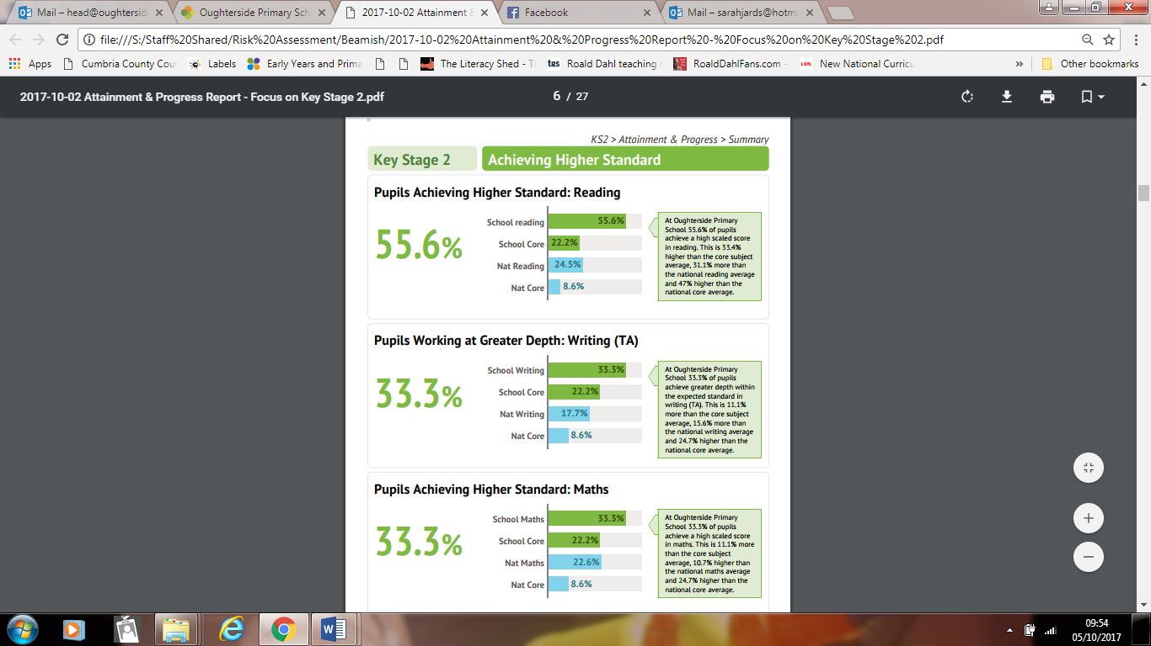

**Our progress at Key Stage 2**

