

**Our results**

We are proud of the results our pupils achieved in 2018. Take a look at how we did.

**EYFS**

60% of our pupils achieved a good level of development (National

**Year 1 phonics screening**

Year 1 – 72% (national 82%)

Year 2 – 75% ( national 92%)

**Key stage 1 Reading**

**Children working at the expected standard**

77% were working at the expected level (national 75%)

0% were working at greater depth

**Key Stage 1 Writing**

**Children working at the expected standard**

66% achieved the expected standard in writing (national 70%)

11% were working at greater depth

**Key Stage 1 Maths**

**Children working at the expected standard**

77% achieved the expected level (national 76%)

22% were working at greater depth

**Our Key stage 2 results 2018**

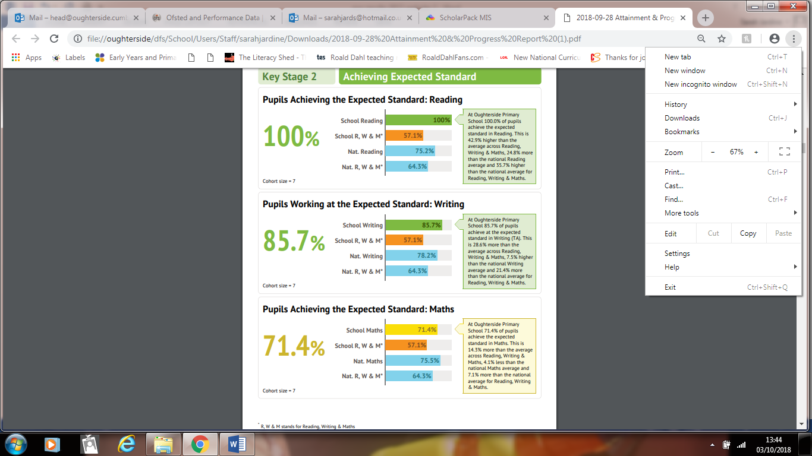

**Our scaled scores were:**

**Reading – 109.1 (national 105.1)**

**Maths – 103.7 (national 104.4)**

**Pupils achieving the higher standard**

**Reading 43% (National 28.1%)**

**Writing 43% (National 19.8%)**

**Maths 43% (National 23.6%)**

**Our progress at Key Stage 2**

**Reading +4.95 (National +0.03)**

**Writing +2.4 (National TBC )**

**Maths +0.50 (National +0.03%)**